- Create ansible playbook to create ansible vault.

Objective
To securely store sensitive credentials using Ansible Vault and use those encrypted variables inside an Ansible playbook.
Prerequisites
- Ansible installed
- Inventory configured (/etc/ansible/hosts)
- Target hosts reachable
- Basic YAML knowledge

Step-by-Step Implementation:

Step 1: Create a variables file
Create a YAML file to store sensitive data.
vi secrets.yml
Add the following content:
user: Aniketh
password: Aniketh@12345

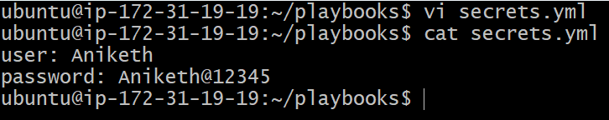

Step 2: Encrypt the variables file using Ansible Vault
Secure the file by encrypting it.
ansible-vault encrypt pass.yml
Enter and confirm the vault password.
File pass.yml is now encrypted.

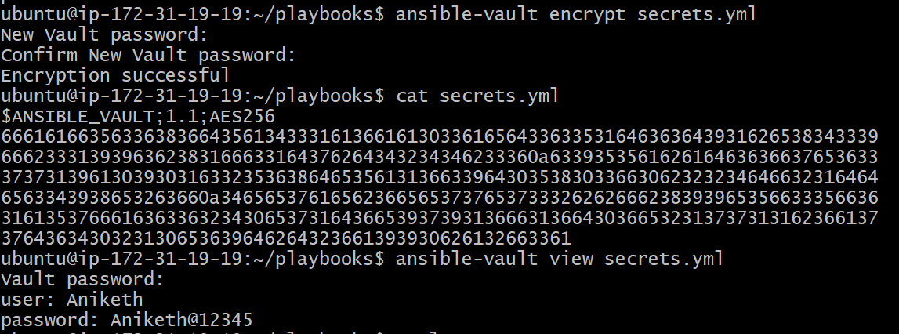

Step 3: Create a playbook to use the vault file
Create a playbook that includes the encrypted variables file.
vi use_vault.yml

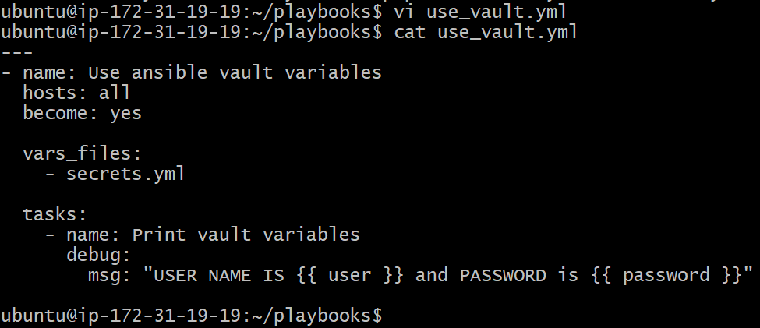

Step 4: Execute the playbook

Run the playbook by providing the vault password.
ansible-playbook use_vault.yml --ask-vault-pass

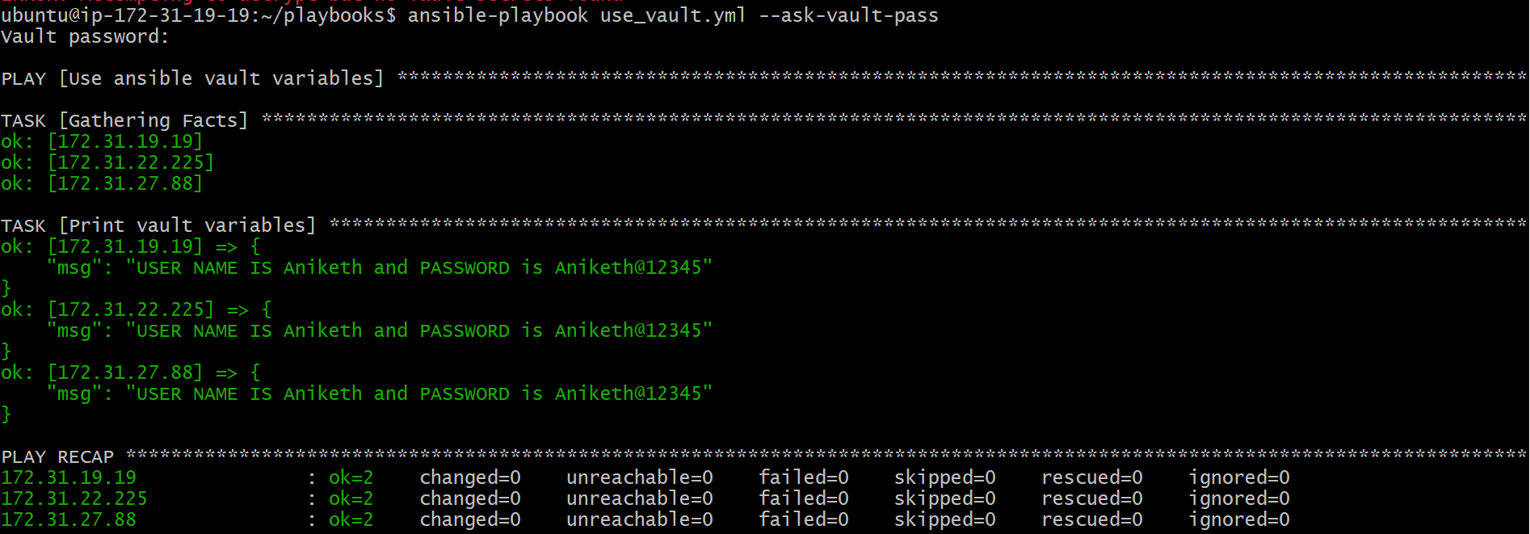

Validation Steps
- Playbook executes without errors
- Vault password prompt appears
- Variables from the encrypted file are successfully accessed
- Task output confirms correct values

- Write a ansible playbook to install apache in linux and ubuntu machine by using when condition.

Objective
To install and start the Apache web server on Ubuntu and RHEL/CentOS/Amazon Linux machines using a single Ansible playbook with OS-based when conditions.
Prerequisites
- Ansible installed on control node
- Inventory configured with Ubuntu and Linux hosts
- SSH connectivity to target machines
- Root or sudo access on target nodes

Step-by-Step Implementation:

Step 1: Create the Ansible playbook
Created a playbook file to handle Apache installation for multiple OS types.
- Added tasks using when condition to identify OS family and install the correct Apache package.
- Configured Apache service to start automatically based on OS.

vi Apache_ubuntu.yml

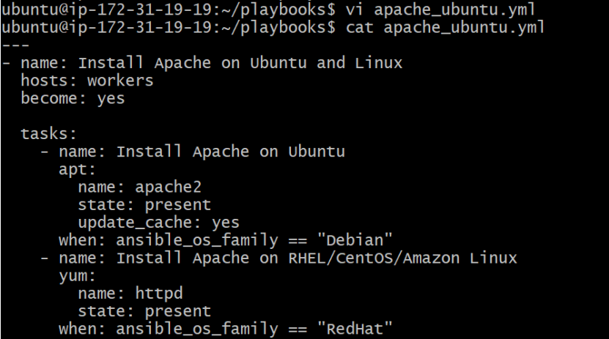
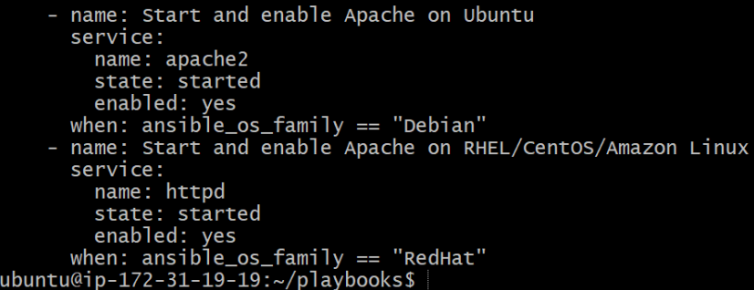

Step 2: Execute the playbook
Ran the playbook on worker . As I mentioned in playbook hosts:workers



ansible-playbook Apache_ubuntu.yml

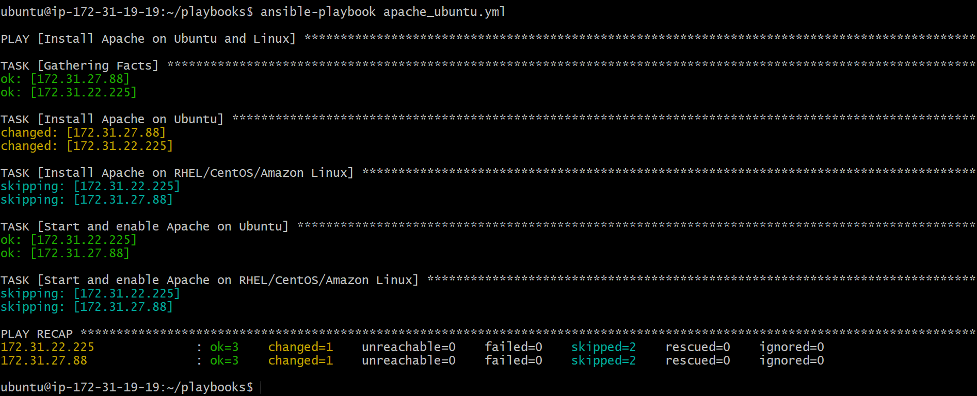

Validation Steps
- Apache installed on Ubuntu systems using apt
- Apache installed on RHEL-based systems using yum
- Apache service started and enabled on applicable systems
- Tasks skipped automatically on non-matching OS
- Play recap shows successful execution with skipped tasks as expected

- Create ansible playbook using roles to configure LAMP stack

Objective
To configure a complete LAMP stack (Apache, MySQL, PHP) on Linux machines using Ansible roles for modular and reusable automation.
Prerequisites
- Ansible installed on control node
- Inventory configured with target hosts
- SSH connectivity and sudo access on target machines
- Ubuntu/Debian-based target servers

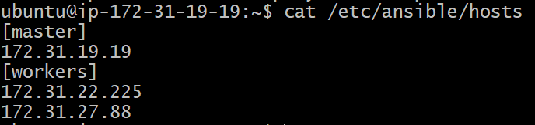

Step-by-Step Implementation:

Step 1: Create LAMP project directory
Created a project directory inside the playbooks directory.
mkdir lamp
cd lamp
Created the main playbook to call roles.
vi roles.yml

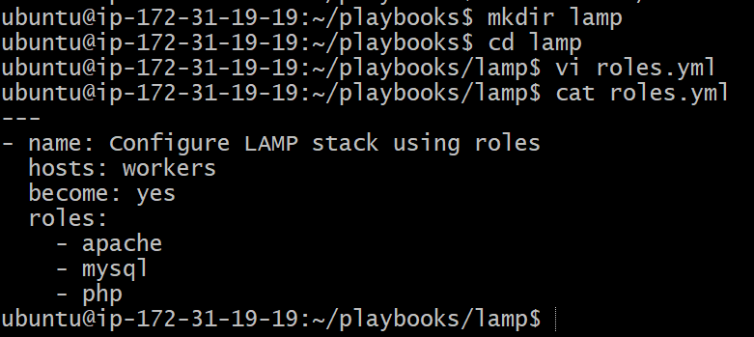

Step 3: Create roles directory structure
Created role directories for Apache, MySQL, and PHP.
ansible-galaxy init apache
ansible-galaxy init mysql
ansible-galaxy init php

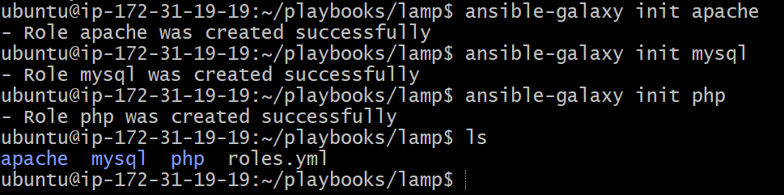

Step 4: Create Apache installation playbook
Defined Apache installation and service management tasks.
vi /apache/tasks/main.yml

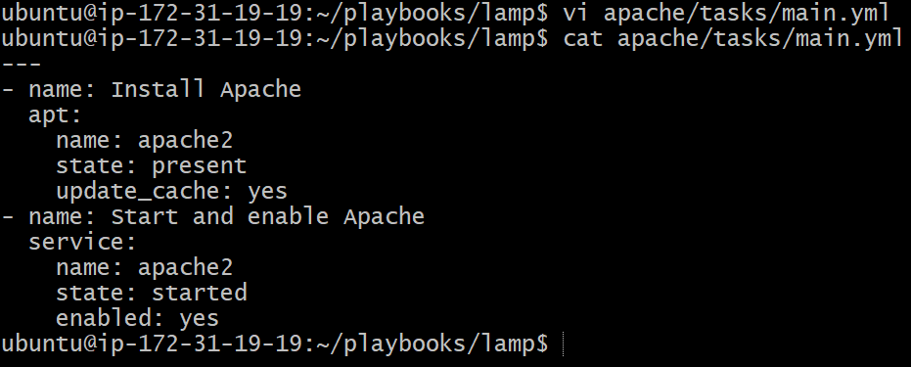
Step 5: Create MySQL role
Defined MySQL installation and service management tasks.
vi /mysql/tasks/main.yml

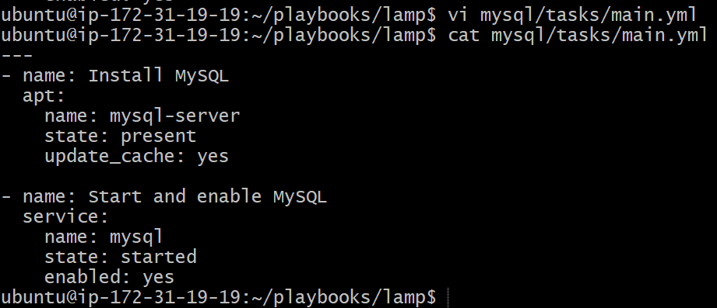
Step 6: Create PHP role
Defined PHP installation and Apache restart tasks.
vi /php/tasks/main.yml

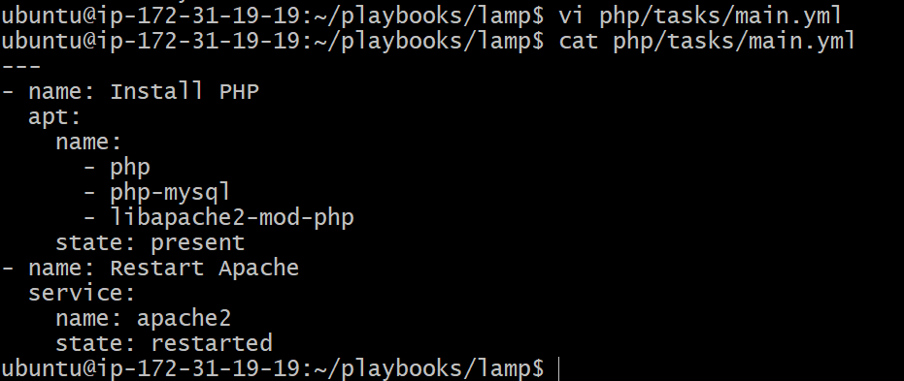

Step 7: Execute the playbook

Ran the playbook to configure the LAMP stack. Based on roles

ansible-playbook roles.yml

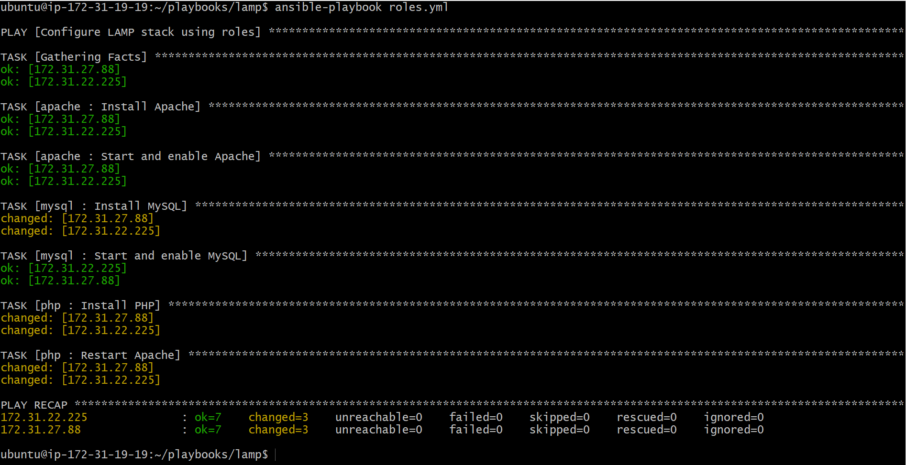

Validation Steps
- Apache service is active and running
- MySQL service is active and running
- PHP packages installed successfully
- Play recap shows successful execution on all hosts
Verification commands:
systemctl status apache2
systemctl status mysql
php -v
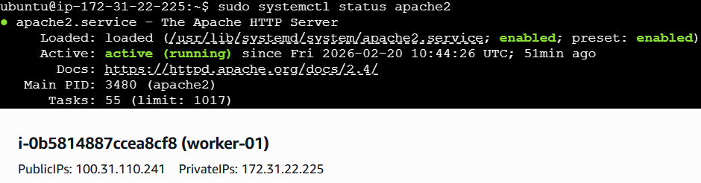
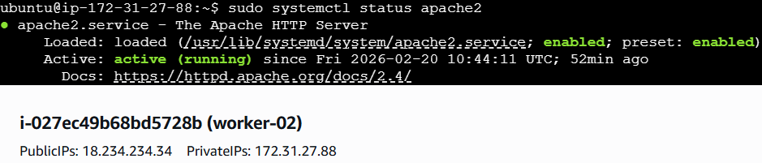
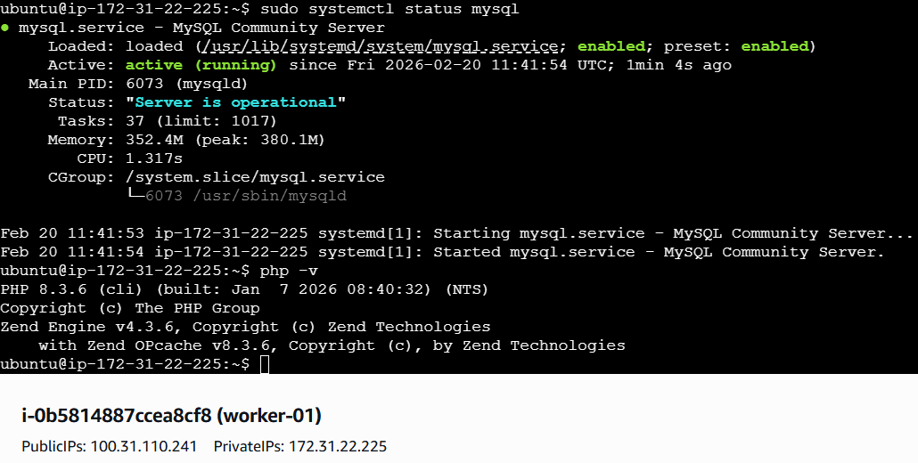
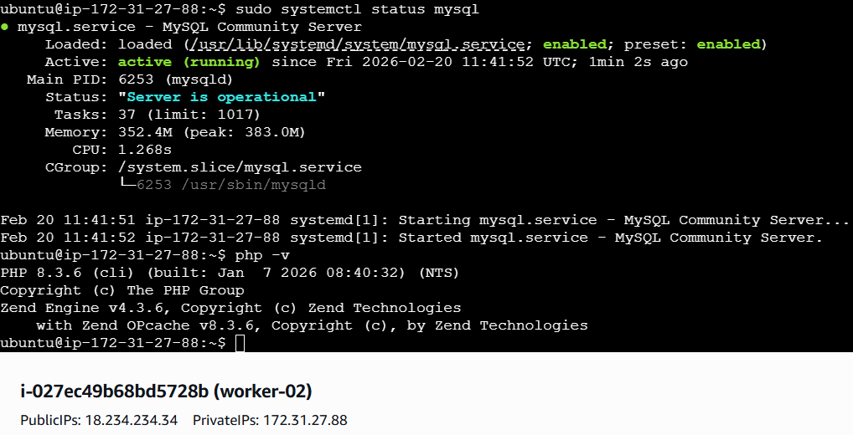

- Setup ansible AWX and explore the options.

Objective
To install Ansible AWX on an Ubuntu EC2 instance using Docker and the Ansible installer, access the AWX Web UI, configure projects and job templates, and successfully execute an Ansible playbook through AWX.
Prerequisites
- Ubuntu EC2 instance running
- Internet access
- Root or sudo privileges
- Ports 80/8052 allowed in security group
- Docker, Docker Compose, Git, and Ansible installed

Step-by-Step Implementation:

Step 1: Provision and access Ubuntu EC2 instance
- Launched EC2 instance for AWX
- Connected to the instance using SSH
Step 2: Update system and install required packages
apt update -y
apt install -y docker.io
apt install docker-compose
apt install git
apt install ansible

Enabled and verified Docker:
systemctl enable docker
systemctl start docker
systemctl status docker

Verified versions:
git --version
docker --version
docker-compose --version
ansible --version

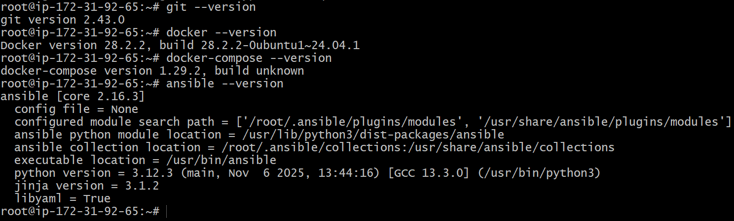

Step 3: Clone Ansible AWX repository
git clone -b 17.1.0 https://github.com/ansible/awx.git
cd awx

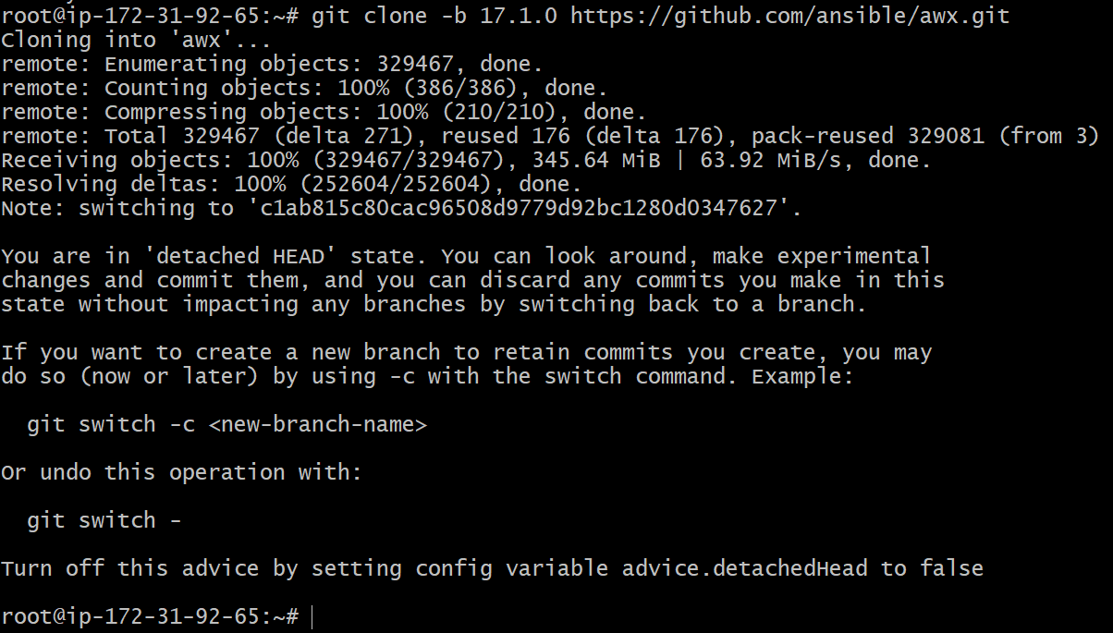

Step 4: Configure AWX installer
Moved to installer directory and edited inventory:
cd installer
vi inventory
add this at the last of inventory file .
admin_password=Admin@123
secret_key=Admin@123
pg_database=awx
pg_password=Admin@123
awx_alternate_dns_servers="8.8.8.8,8.8.4.4"
postgres_data_dir="/var/lib/awx/pgdocker"
docker_compose_dir="/var/lib/awx/awxcompose"
project_data_dir="/var/lib/awx/projects"

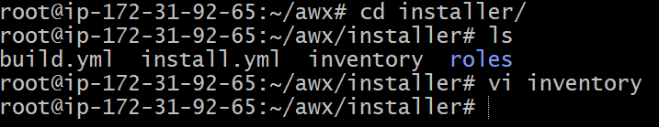

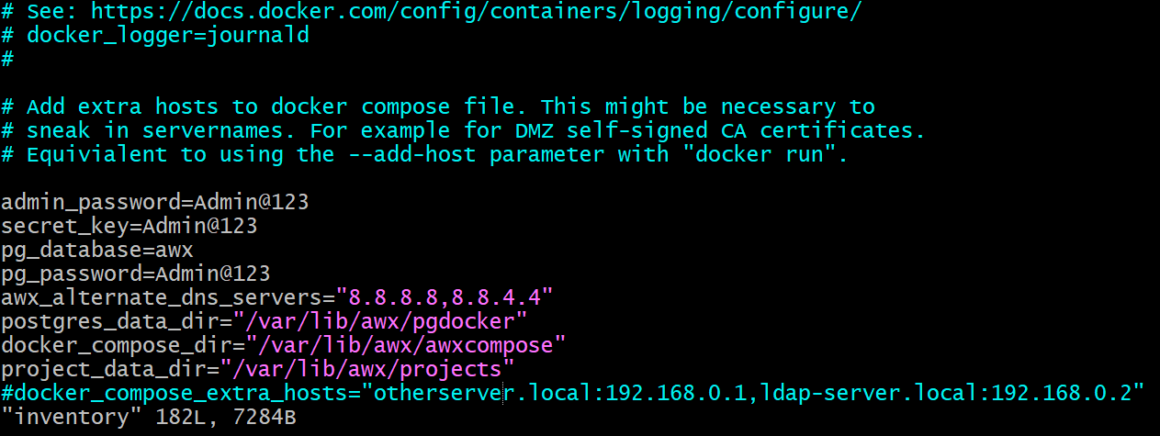

Step 5: Install AWX

Executed AWX installation playbook:
ansible-playbook -i inventory install.yml
(or)
ansible-playbook -i ~/awx/installer/inventory ~/awx/installer/install.yml

Installer performed:
- Docker container creation
- Database migrations
- Service initialization
- Preload data creation

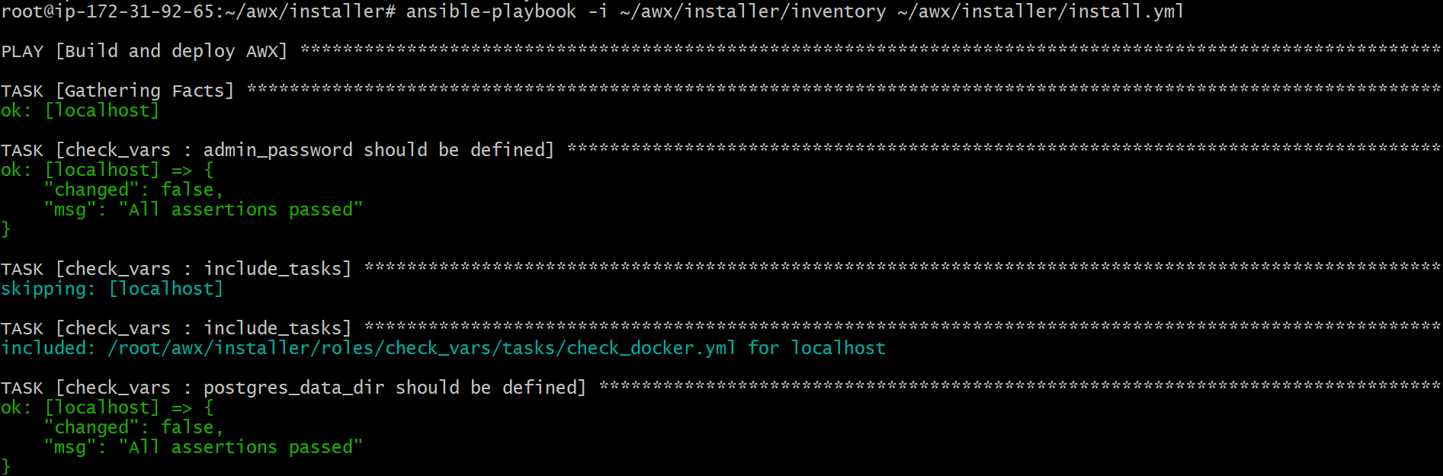
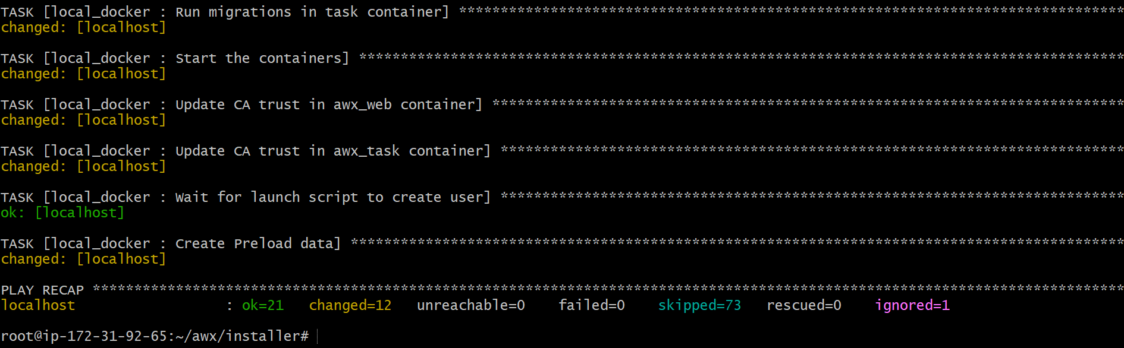

Step 6: Verify AWX containers
docker ps
Confirmed containers:
- awx_web
- awx_task
- awx_postgres
- Redis

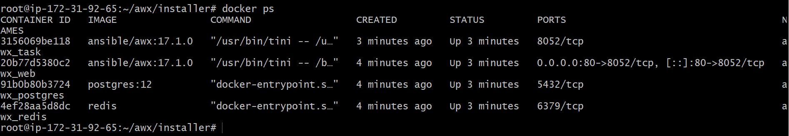

Step 7: Access AWX Web UI
- Opened browser and accessed:
http://<public-ip>
- AWX login page displayed
- Logged in using admin credentials
{user = admin password= Admin@123}
- Dashboard loaded successfully

